**EDA with Visualization Lab**

This **environment** is to do the **Peer Graded Assignment**.

In case you need to **download** the lab **notebook** (.**ipynb file**)

* click [HERE](https://cf-courses-data.s3.us.cloud-object-storage.appdomain.cloud/IBM-DS0321EN-SkillsNetwork/labs/module_2/jupyter-labs-eda-dataviz.ipynb) to **download** the lab **notebook** or
* open the **lab** by clicking this [link](https://cf-courses-data.s3.us.cloud-object-storage.appdomain.cloud/IBM-DS0321EN-SkillsNetwork/labs/module_2/jupyter-labs-eda-dataviz.ipynb.jupyterlite.ipynb.html).

<https://cf-courses-data.s3.us.cloud-object-storage.appdomain.cloud/IBM-DS0321EN-SkillsNetwork/labs/module_2/jupyter-labs-eda-dataviz.ipynb.jupyterlite.ipynb.html>

Once you **complete the lab** you can **download** the **notebook** as follows:

* Select the **notebook** which is displayed in the left **Navigation pane**
* **Right click** on it & click on the **Download** option.
* Your **notebook** gets **downloaded**.

Later **upload** to **GitHub** by following the instructions in the reading [Getting Started with GitHub .](https://cf-courses-data.s3.us.cloud-object-storage.appdomain.cloud/IBMDeveloperSkillsNetwork-DS0105EN-SkillsNetwork/labs/Module2/GitHub1_Getting_Started.md.html?origin=www.coursera.org)

Further in the **MySubmission tab** of the assignment

* paste the **GitHub** **link** of the **notebook** in the **URL textbox.**

[](https://skills.network/?utm_medium=Exinfluencer&utm_source=Exinfluencer&utm_content=000026UJ&utm_term=10006555&utm_id=NA-SkillsNetwork-Channel-SkillsNetworkCoursesIBMDS0321ENSkillsNetwork26802033-2022-01-01)

**SpaceX Falcon 9 First Stage Landing Prediction**

**Assignment: Exploring and Preparing Data**

Estimated time needed: **70** minutes

In this **assignment**, we will **predict**

* if the **Falcon 9 1st stage** will **land** **successfully**.

**SpaceX**

* advertises **Falcon** **9** **rocket launches** on its **website**,
* with a **cost** of **62** **million** **dollars**;

Other **Rocket** **providers**

* **cost** **upward** of **165** **million dollars** **each**, much of the **savings** is!
* b/c **SpaceX** can **reuse** the **1st** **stage**.

In this lab, we will perform

* **Exploratory Data Analysis** & **Feature Engineering**.

We will mainly **convert** those **outcomes** into **Training** **Labels** with

* **1**means the **booster** **successfully** **landed**
* **0** means it was **unsuccessful.**

**Falcon 9 first stage**

* will **land** **successfully**

Several examples of an **unsuccessful** **landing** are shown **below**:



Most **unsuccessful** **landings**

* are **planned** as shown on the **Right**.

**Space X**

* performs a **controlled** **landing** in the **oceans**.

**Objectives**

* Perform **exploratory Data Analysis** and **Feature Engineering**
* using **Pandas** and **Matplotlib**
* **Exploratory Data Analysis**
* Preparing **Data Feature Engineering**

**Import Libraries and Define Auxiliary Functions**

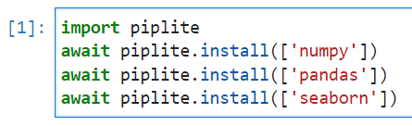We will **import** the following **libraries** the lab

**import piplite**

**await piplite.install(['numpy'])**

**await piplite.install(['pandas'])**

**await piplite.install(['seaborn'])**

*# pandas is a software library written for the Python programming language for data manipulation and analysis.*

**import pandas as pd**

*#NumPy is a library for the Python programming language, adding support for large, multi-dimensional arrays and matrices, along with a large collection of high-level mathematical functions to operate on these arrays*

**import numpy as np**

*# Matplotlib is a plotting library for python and pyplot gives us a MatLab like plotting framework. We will use this in our plotter function to plot data.*

**import matplotlib.pyplot as plt**

*#Seaborn is a Python data visualization library based on matplotlib. It provides a high-level interface for drawing attractive and informative statistical graphics*

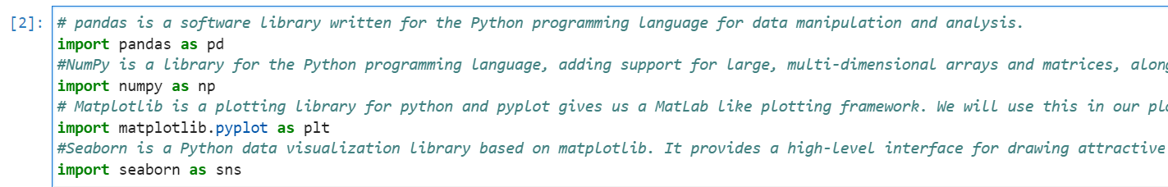**import seaborn as sns**

***## Exploratory Data Analysis***

​**1st**, let's **read** the **SpaceX dataset** into a **Pandas** **dataframe** &

* **print** its **summary**

**from js import fetch**

**import io​**

**URL = "https://cf-courses-data.s3.us.cloud-object-storage.appdomain.cloud/IBM-DS0321EN-SkillsNetwork/datasets/dataset_part_2.csv"**

**resp = await fetch(URL)**

**dataset_part_2_csv = io.BytesIO((await resp.arrayBuffer()).to_py())**

**df=pd.read_csv(dataset_part_2_csv)**

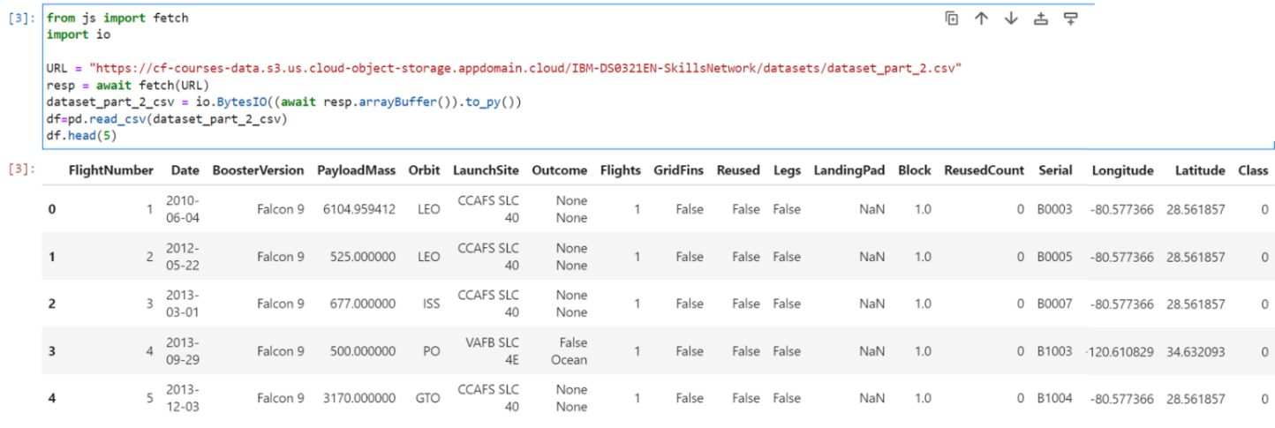**df.head(5)**

**1st**, let's try to see how

* the **FlightNumber** (indicating the **continuous** **launch** **attempts**.) &
* **Payload** **variables**
* would **affect** the **launch** **outcome**.

We can **plot out** the **FlightNumber** **vs**. **PayloadMass** &

* **overlay** the **outcome** of the **launch**.

We see that as the **flight number** **increases**,

* the **1st stage** is **more likely** to **land** **successfully**.

The **payload mass** is also important;

* it seems the **more massive** the **payload**,
* the **less likely** the **1st stage** will return.

**sns.catplot(y="PayloadMass", x="FlightNumber", hue="Class", data=df, aspect = 5)**

**plt.xlabel("Flight Number",fontsize=20)**

**plt.ylabel(****"Pay load Mass (kg)",fontsize=20)**

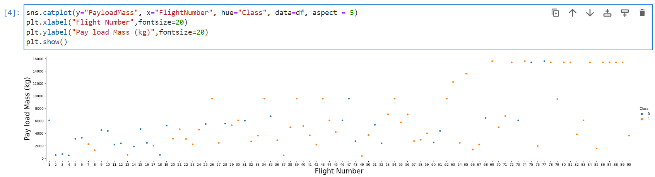**plt.show()**

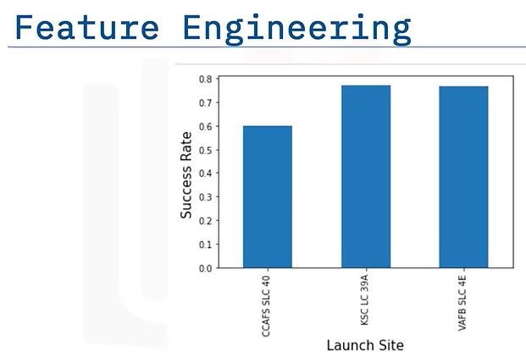We see that **different** **launch sites**

* have **different** **success rates**.

**CCAFS LC-40**,

* has a **success rate** of **60 %**,

while**KSC LC-39A**and **VAFB SLC 4E**

* has a **success rate** of **77%**.

Next, let's drill down to each **launch site**

* to **visualize** its **detailed** **launch** **records**.

***### TASK 1: Visualize the relationship between Flight Number and Launch Site***

​Use the **function** **catplot**

**df.catplot**

**df.plot(kind='scatter', x=** **‘FlightNumber’, y= ‘****Launch Site’ , figsize=(10, 6), color='darkblue')​**

**plt.title(‘FlightNumber vs LaunchSite’)**

**plt.xlabel(‘FlightNumber’)**

**plt.ylabel(‘Launch Site)​**

**plt.show()**

* to **plot** **FlightNumber** vs **LaunchSite**,
* set the **parameter** **x** to **FlightNumber**,
* set the **parameter** **y** to **Launch Site** and
* set the **parameter** **hue** to **'class'**

*# Plot a scatter point chart with x axis to be Flight Number and y axis to be the launch site, and hue to be the class value*

**sns.catplot(y="Launch Site", x="FlightNumber", hue="Class", data=df, aspect = 5)**

**plt.xlabel("Flight Number",fontsize=20)**

**plt.ylabel("****Launch Site",fontsize=20)**

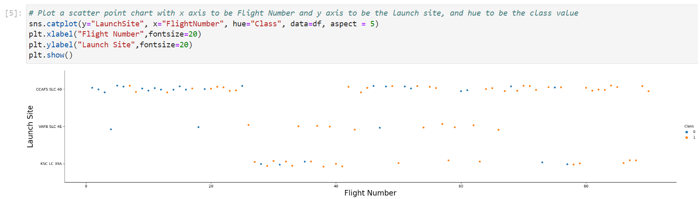**plt.show()**

Now try to explain the **patterns** you found in the

* **Flight Number** vs. **Launch Site** **scatter point plots**.

In the **CCAFS LC-40** **launchsite**

* the **Success** appears **related** to the **nos.** of **flights**;

while in the**KSC LC-39A**& **VAFB SLC 4E** **launchsites**

* **success** seems to have **no** **r/ship** with the **flight** **numbers**

Next, let's drill down to each **launch site**

* to **visualize** its **detailed** **launch** **records**.

***### TASK 2: Visualize the relationship between Payload and Launch Site***

​We also want to observe if there is any **r/ship** b/n

* **launch sites** & their **payload mass**.

*# Plot a scatter point chart with x axis to be Pay Load Mass (kg) and y axis to be the launch site, and hue to be the class value*

**sns.catplot(y="LaunchSite", x= “PayloadMass", hue="Class", data=df, aspect = 5)**

**plt.xlabel("****Pay load Mass (kg)",fontsize=20)**

**plt.ylabel("Launch Site",fontsize=20)**

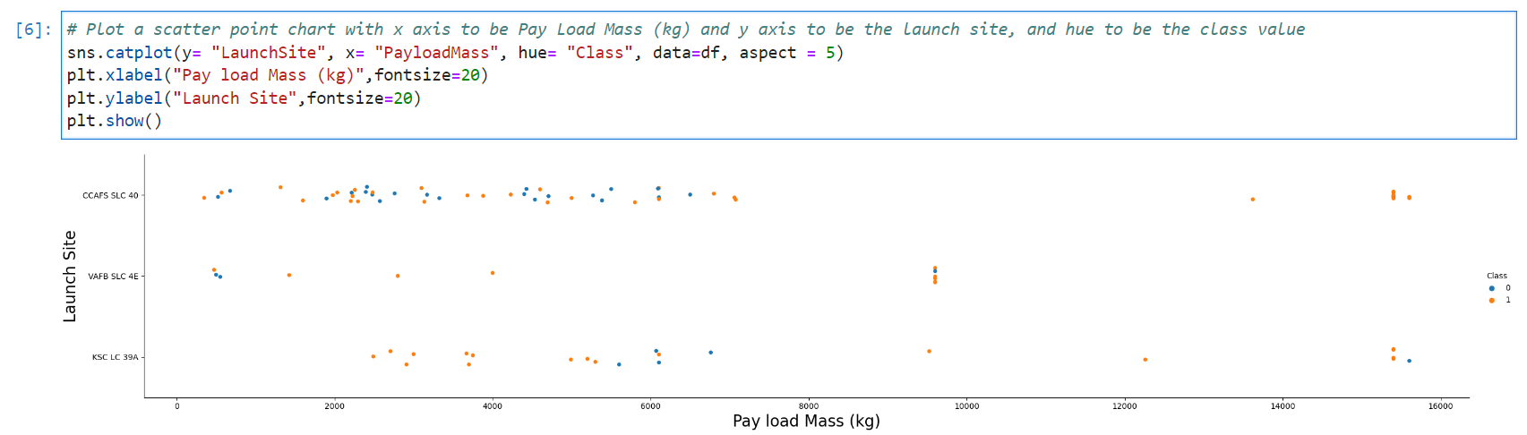**plt.show()**

Now if you observe **Payload** Vs. **Launch Site** **scatter point** **chart**

you will find for the **VAFB-SLC** **launchsite**

* there are **no** **rockets** **launched** for **heavypayload** **mass**(**>** **10000**).

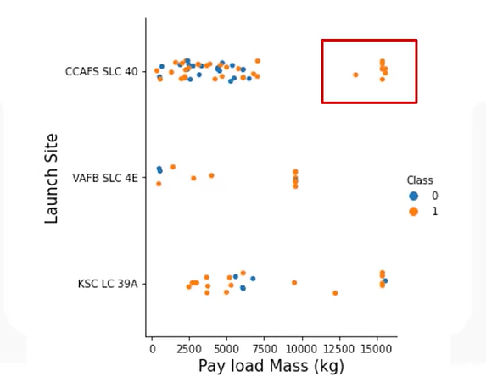

Now if you observe **Payload** Vs. **Launch Site** **scatter point** **chart**

you will find for the **VAFB-SLC** **launchsite**

* there are **no** **rockets** **launched** for **heavypayload** **mass**(**>** **10000**).

***### TASK 3: Visualize the relationship between success rate of each orbit type***

​Next, we want to visually check

* if there are any **r/ship** b/n **success rate** & **orbit type**.

Let's create a **bar chart** for the **success rate** of each **orbit**

**# HINT** use **groupby** method on **Orbit** column and get the **mean** of **Class** column

**df.groupby('Orbit')['Class'].mean().****plot(kind='bar', figsize=(10, 6))**

**plt.xlabel("Orbit Type", fontsize=10)**

**plt.ylabel("Success Rate", fontsize=10)**

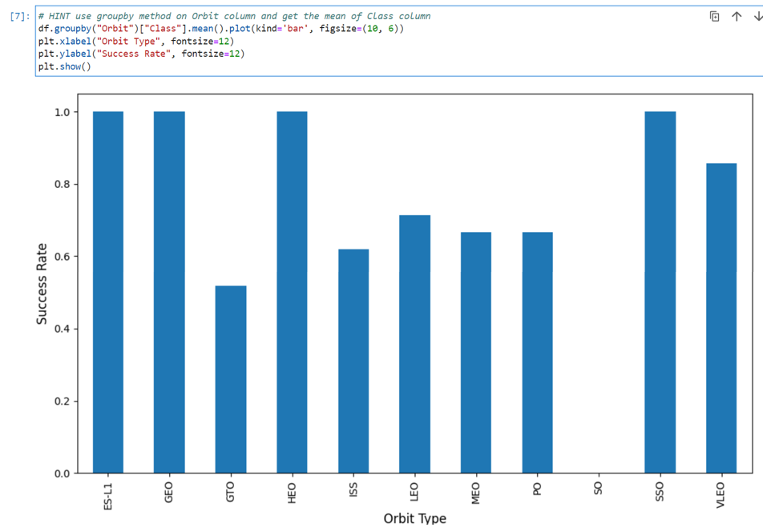**plt.show()**

**Analyze** the **plotted** **bar** **chart** & try to find

which **orbits** have **high** **success** **rate**.

* **ES-L1, GEO, HEO, SS0, 100%**
* **VLEO, 90%**
* **LEO, 70%**
* **MEO, PO, 65%**
* **ISS, 60%**

***### TASK 4: Visualize the relationship between FlightNumber and Orbit type***

​For each **orbit**, we want to see if there is any **r/ship** b/n

* **FlightNumber** & **Orbit type**.

# Plot a scatter point chart with x axis to be FlightNumber and y axis to be the Orbit, and hue to be the class value

**sns.catplot(y="Orbit", x="FlightNumber", hue="Class", data=df, aspect = 5)**

**plt.xlabel("Flight Number",fontsize=20)**

**plt.ylabel("Orbit Type",fontsize=20)**

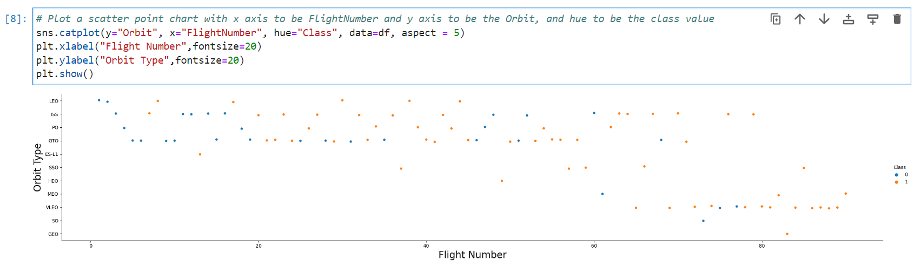**plt.show()**

You should see that in the **LEO** **orbit**

* the **Success** appears **related** to the **nos.** of **flights**;

on the other hand, when in **GTO** **orbit**.

* there seems to be **no** **r/ship** b/n **flight** **number**

***### TASK 5: Visualize the relationship between Payload and Orbit type***

​Similarly, we can **plot** the **Payload** vs. **Orbit** **scatter point** **charts**

* to reveal the **r/ship** b/n **Payload** and **Orbit type**

# Plot a scatter point chart with x axis to be Payload and y axis to be the Orbit, and hue to be the class value

**sns.catplot(y="Orbit", x="Payload", hue="Class", data=df, aspect = 5)**

**plt.xlabel("Pay load Mass (kg )", fontsize=20)**

**plt.ylabel("Orbit Type", fontsize=20)**

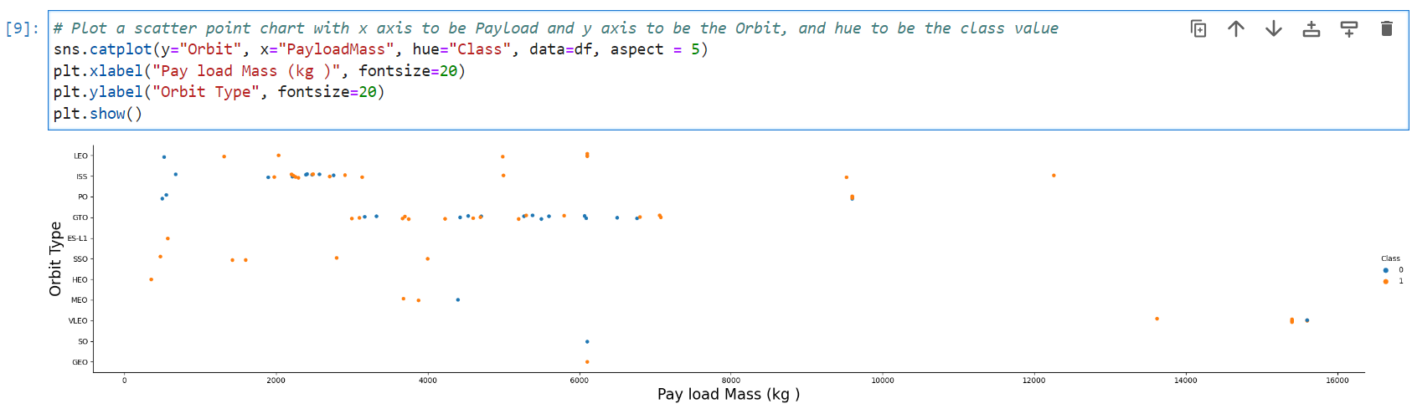**plt.show()**

With **heavy** **payloads**

* the **successful** **landing** / **+ve** **landing** **rate**
* are **more** for **Polar** (**PO)**, **LEO** and **ISS**.

However, we cannot distinguish well

* this **successful** **landing** / **+ve** **landing** **rate** for **GTO**
* as both **+ve** **landing** **rate** & **-ve** **landing** (**unsuccessful** **mission**) are found. there.

***### TASK 6: Visualize the launch success yearly trend***

​You can **plot** a **line chart** with

* **x axis** to be **Year** and
* **y axis** to be **average** **success rate**,
* to get the **average** **launch success** **trend**.

The **function** will help you get the **year** from the **date**:

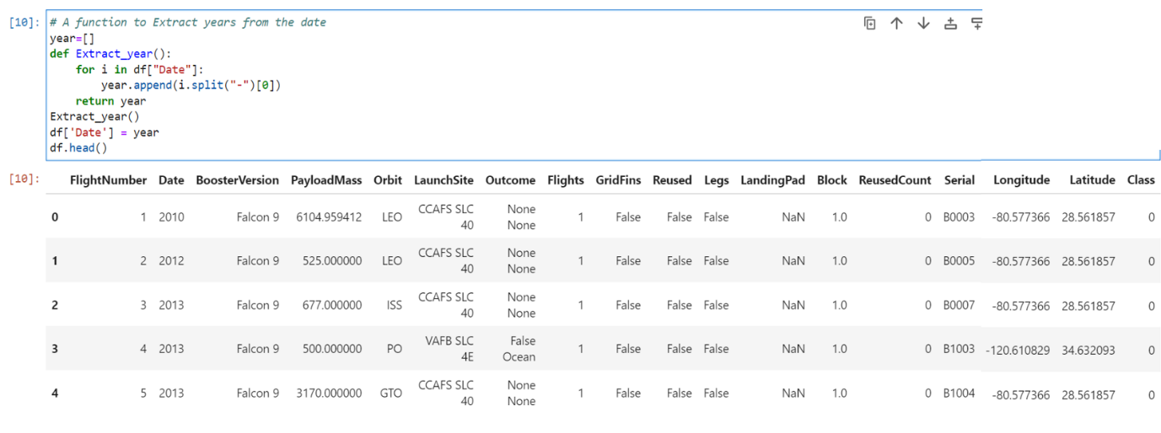# A function to Extract years from the date

**year=[]**

**def Extract_year():**

**for i in df["Date"]:**

**year.append(i.split("-")[0])**

**return year**

**Extract_year()**

**df['Date'] = year**

**df.head()**

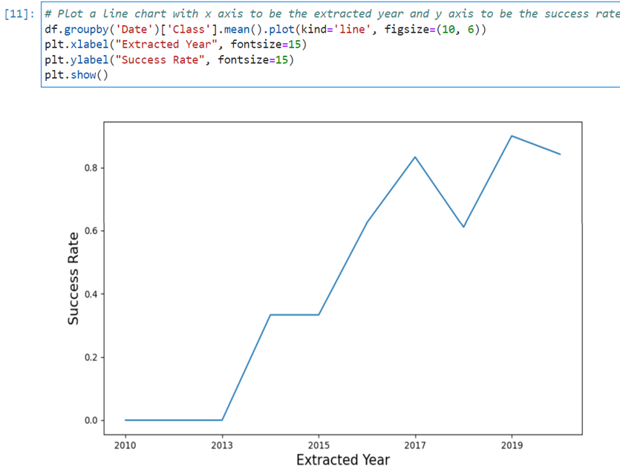# Plot a line chart with x axis to be the extracted year and y axis to be the success rate

**df.groupby('Date')['Class'].mean().plot(kind='line', figsize=(10, 6))**

**plt.xlabel("Extracted Year", fontsize=15)**

**plt.ylabel("Success Rate", fontsize=15)**

**plt.show()**

you can observe that

* the **success rate** since **2013**
* kept **increasing** till **2020**

***## Features Engineering***

​By now, you should obtain some **preliminary** **insights**

* about how each important **variable** would **affect** the **success** **rate**,

we will select the **features**

* that will be used in **success** **prediction** in the future **module**.

**features = df[['FlightNumber', 'PayloadMass', 'Orbit', 'LaunchSite', 'Flights', 'GridFins', 'Reused', 'Legs', 'LandingPad', 'Block', 'ReusedCount', 'Serial']]**

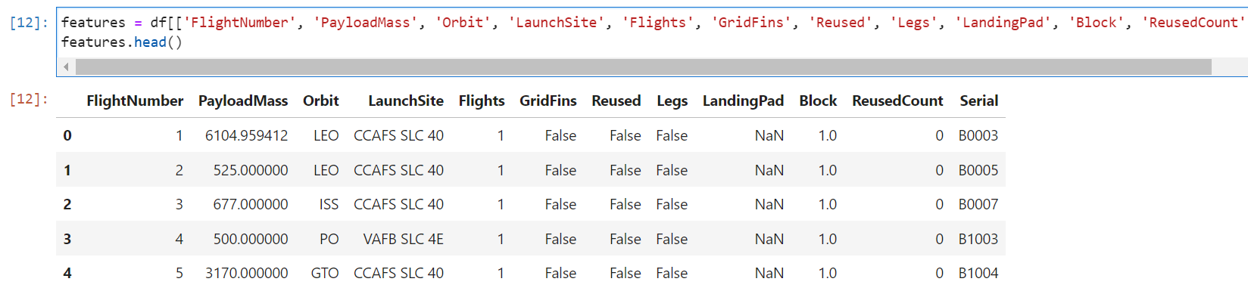**features.head()**

***### TASK 7: Create dummy variables to categorical columns***

​Use the **function** **get_dummies** & **features** **dataframe**

* to apply **OneHotEncoder** to the **column** **Orbits**, **LaunchSite**, **LandingPad**, and **Serial**.

**Assign** the **value** to the **variable** **features_one_hot**,

* display the **results** using the **method** **head**.

Your **result** **dataframe** must include

* all **features** including the **encoded** ones.

*# HINT: Use get_dummies() function on the categorical columns*

**features_one_hot = pd.get_dummies(data=features, prefix=****["Orbits","LaunchSite","LandingPad","Serial"])**

***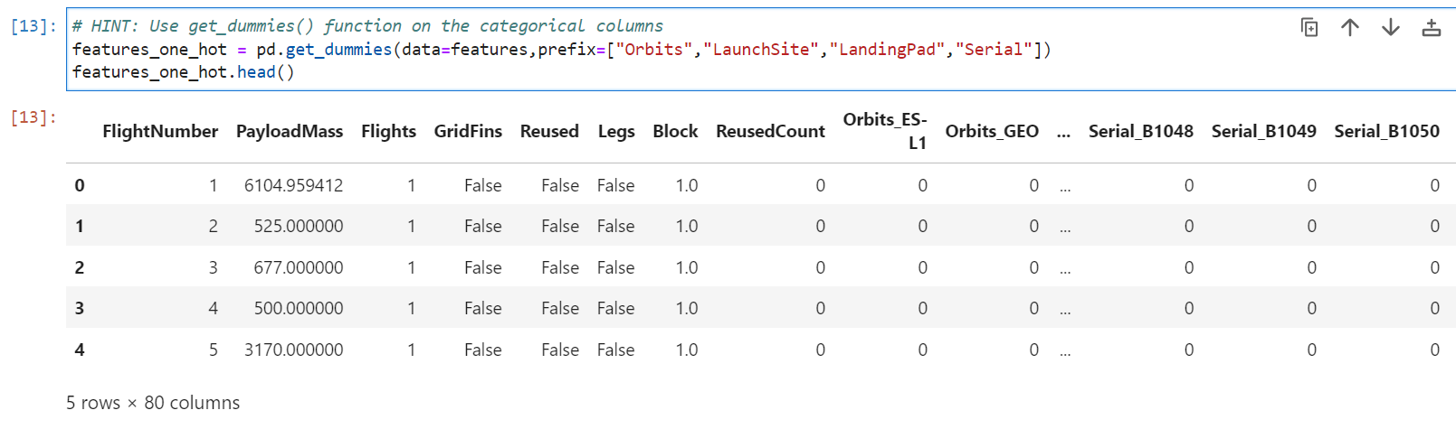*features_one_hot.head()**

***### TASK 8: Cast all numeric columns to `float64`***

​Now that our **features_one_hot** **dataframe**

* only contains **numbers** & so
* **cast** the **entire** **dataframe** to **variable** **type** **float64**

*# HINT: use astype function*

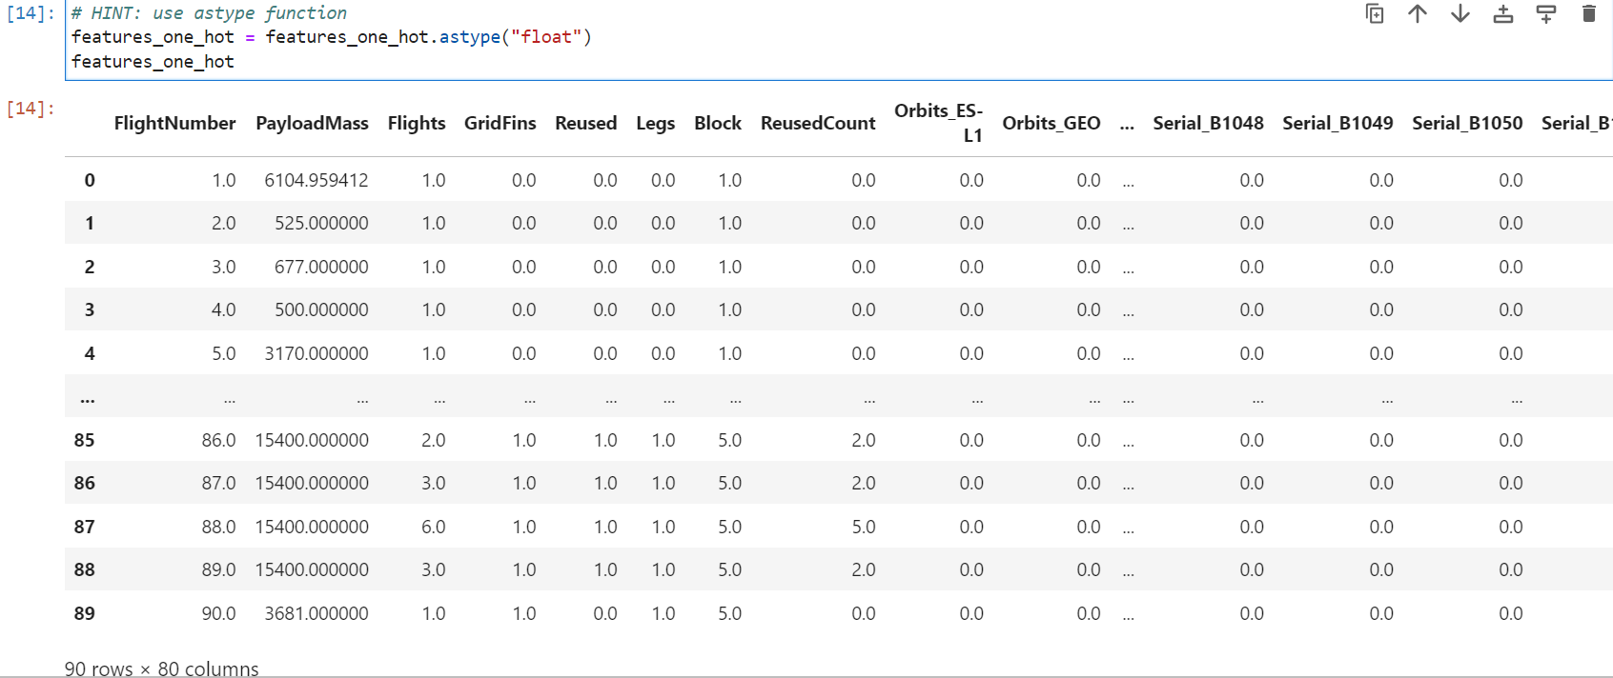**features_one_hot = features_one_hot.astype("float")**

**# HINT use groupby method on LaunchSite column and get the mean of Class column**

**df.groupby("LaunchSite")["Class"].mean().plot(kind='bar', figsize=(18, 12))**

**plt.xlabel("Launch Site", fontsize=12)**

**plt.ylabel("Success Rate", fontsize=12)**

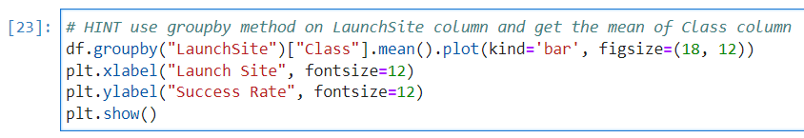**plt.show()**

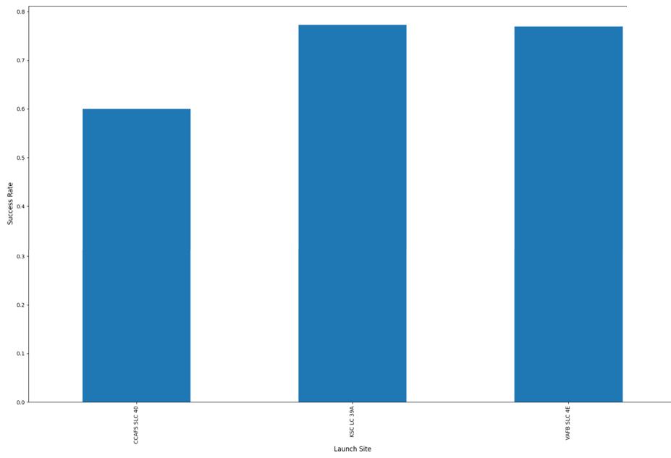

We can now **export** it to a **CSV** for the next section,

but to make the answers **consistent**,

in the next lab we will provide data in a **pre-selected** **date range**.

* **features_one_hot.to_csv('dataset_part_3.csv', index=False)**

**GithHub link**

https://github.com/abiyselassie22/testpro/blob/master/IBM-DS0321EN-SkillsNetwork_labs_module_2_jupyter-labs-eda-dataviz.ipynb.jupyterlite.ipynb

https://github.com/abiyselassie22/caprepo/blob/master/module_2_jupyter-labs-eda-dataviz.ipynb.jupyterlite.ipynb

**Authors**

[Pratiksha Verma](https://www.linkedin.com/in/pratiksha-verma-6487561b1/?utm_medium=Exinfluencer&utm_source=Exinfluencer&utm_content=000026UJ&utm_term=10006555&utm_id=NA-SkillsNetwork-Channel-SkillsNetworkCoursesIBMDS0321ENSkillsNetwork865-2022-01-01)

**Change Log**

**Quizzes**

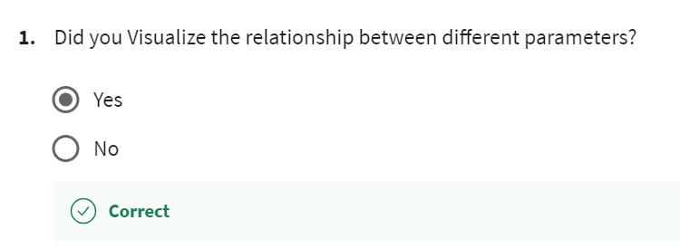

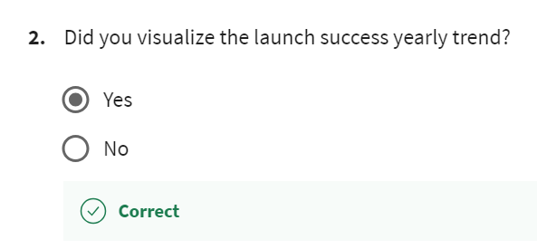

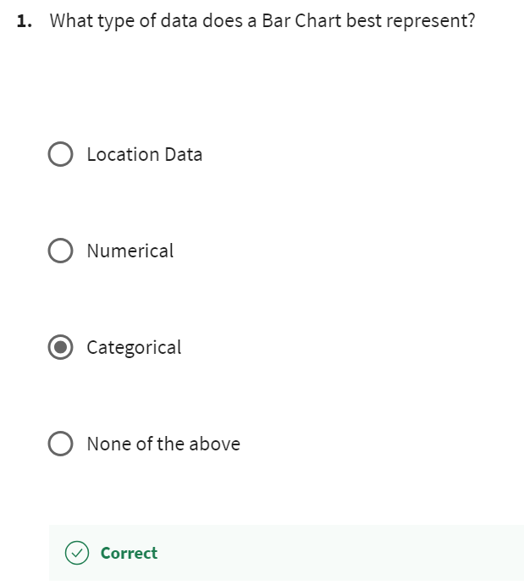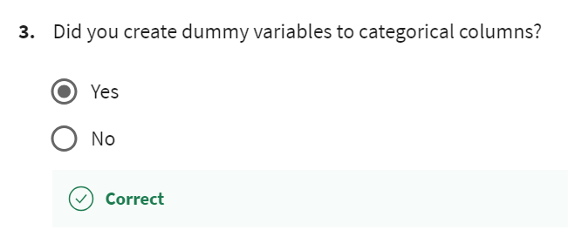

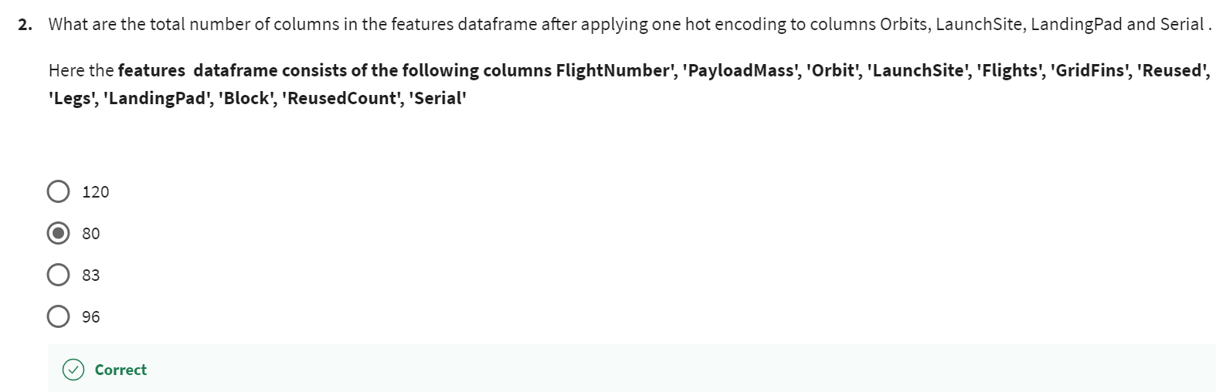

**Bar charts**

* represents **categorical** **data** in **rectangular** **bars**.
* Each **category** is defined on **1** **axis**, &
* the **value** **counts** for this **category** are represented on **another** **axis**.
* Each **bar** has **discrete** **values**
* are generally used to **compare** **values**.

We can use **bar** **plots** in **visualizing**:

* **Pizza delivery time** in **peak** & **non**-**peak** **hours**
* **Population** **comparison** by **gender**
* **No**. of **views** by **movie name**
* **average pass** **percentage** of **classes** from **grade 6** to **grade 10​**
* **%** **percentage of success** **rates** of **different** **orbits**



